CO- 2: AT – 2: Simulation Task - Medium
COURSE NAME: 5G / 6G Communication Systems
COURSE CODE: ECA5604
NAME: VENKATESHWAR REDDY. N
REG: 192312193
36. Simulation of V2X Communication
Objective:
To simulate V2X communication performance by analyzing latency, vehicle speed, packet delivery ratio, throughput, and interference.
Parameters: Latency, Vehicle Speed, Packet Delivery Ratio (PDR), Throughput, Interference
MATLAB CODE:
clc;
clear;
close all;
speed = 20:10:120;
latency = 5 + 0.08*speed;
PDR = 99 - 0.15*speed;
throughput = 25 - 0.05*speed;
interference = 2 + 0.12*speed;
figure;
subplot(2,2,1);
plot(speed,latency,'-o','LineWidth',2);
xlabel('Vehicle Speed (km/h)');
ylabel('Latency (ms)');
grid on;
subplot(2,2,2);
plot(speed,PDR,'-s','LineWidth',2);
xlabel('Vehicle Speed (km/h)');
ylabel('Packet Delivery Ratio (%)');
grid on;
subplot(2,2,3);
plot(speed,throughput,'-*','LineWidth',2);
xlabel('Vehicle Speed (km/h)');
ylabel('Throughput (Mbps)');
grid on;
subplot(2,2,4);
plot(speed,interference,'-d','LineWidth',2);
xlabel('Vehicle Speed (km/h)');
ylabel('Interference');
grid on;
OUTPUT
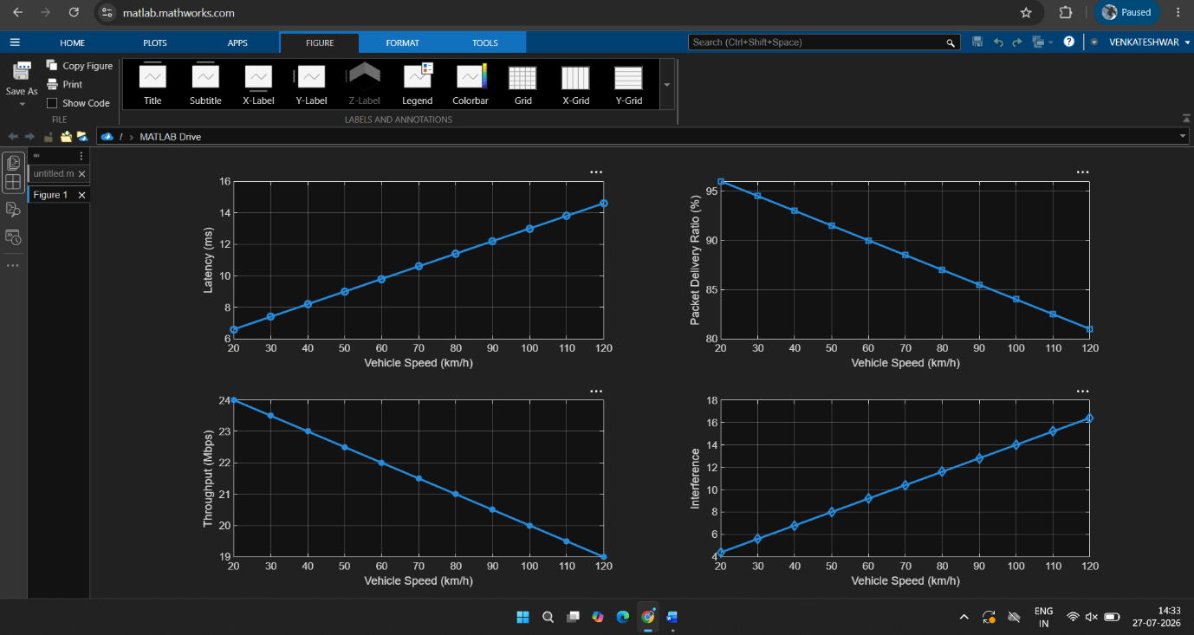

RESULT:
The V2X communication system was successfully simulated in MATLAB. The results show that as vehicle speed increases, latency and interference increase, while packet delivery ratio and throughput decrease, indicating the impact of mobility on communication performance.

37. Simulation of NB-IoT Performance
Objective:
To evaluate NB-IoT performance under varying coverage, delay, power consumption, throughput, and packet loss.
Parameters: Coverage, Delay, Power Consumption, Throughput, Packet Loss
MATLAB CODE:
clc;
clear;
close all;

coverage = 1:10;
delay = 40 + 5*coverage;
power = 120 - 8*coverage;
throughput = 15 - 0.8*coverage;
packetLoss = 1 + 0.5*coverage;

figure;
subplot(2,2,1);
plot(coverage,delay,'LineWidth',2);
xlabel('Coverage Level');
ylabel('Delay (ms)');
grid on;

subplot(2,2,2);
plot(coverage,power,'LineWidth',2);
xlabel('Coverage Level');
ylabel('Power Consumption (mW)');
grid on;
subplot(2,2,3);
plot(coverage,throughput,'LineWidth',2);
xlabel('Coverage Level');
ylabel('Throughput (kbps)');
grid on;
subplot(2,2,4);
plot(coverage,packetLoss,'LineWidth',2);
xlabel('Coverage Level');
ylabel('Packet Loss (%)');
grid on;
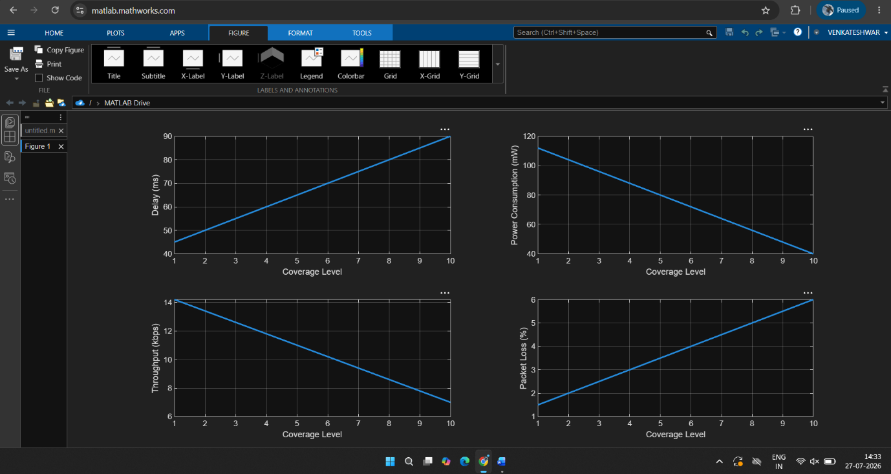
OUTPUT:

RESULT:
The NB-IoT network performance was successfully simulated. The simulation shows that increasing coverage results in higher delay and packet loss, while throughput decreases and power consumption reduces, demonstrating the trade-off between coverage and network performance.

38. Simulation of Edge Computing Delay
Objective:
To analyze edge computing delay by comparing local processing and cloud processing under different latency, bandwidth, and task sizes.
Parameters: Local Processing, Cloud Processing, Latency, Bandwidth, Task Size
MATLAB CODE:
clc;
clear;
close all;

task = 1:20;

localDelay = 2*task;
cloudDelay = 5 + 1.2*task;
latency = cloudDelay - localDelay;
bandwidth = 100 - 2*task;
figure;
subplot(2,2,1);
plot(task,localDelay,'LineWidth',2);
xlabel('Task Size (MB)');
ylabel('Local Delay (ms)');
grid on;
subplot(2,2,2);
plot(task,cloudDelay,'LineWidth',2);
xlabel('Task Size (MB)');
ylabel('Cloud Delay (ms)');
grid on;
subplot(2,2,3);
plot(task,latency,'LineWidth',2);
xlabel('Task Size (MB)');
ylabel('Delay Difference (ms)');
grid on;
subplot(2,2,4);
plot(task,bandwidth,'LineWidth',2);
xlabel('Task Size (MB)');
ylabel('Bandwidth (Mbps)');
grid on;
OUTPUT:
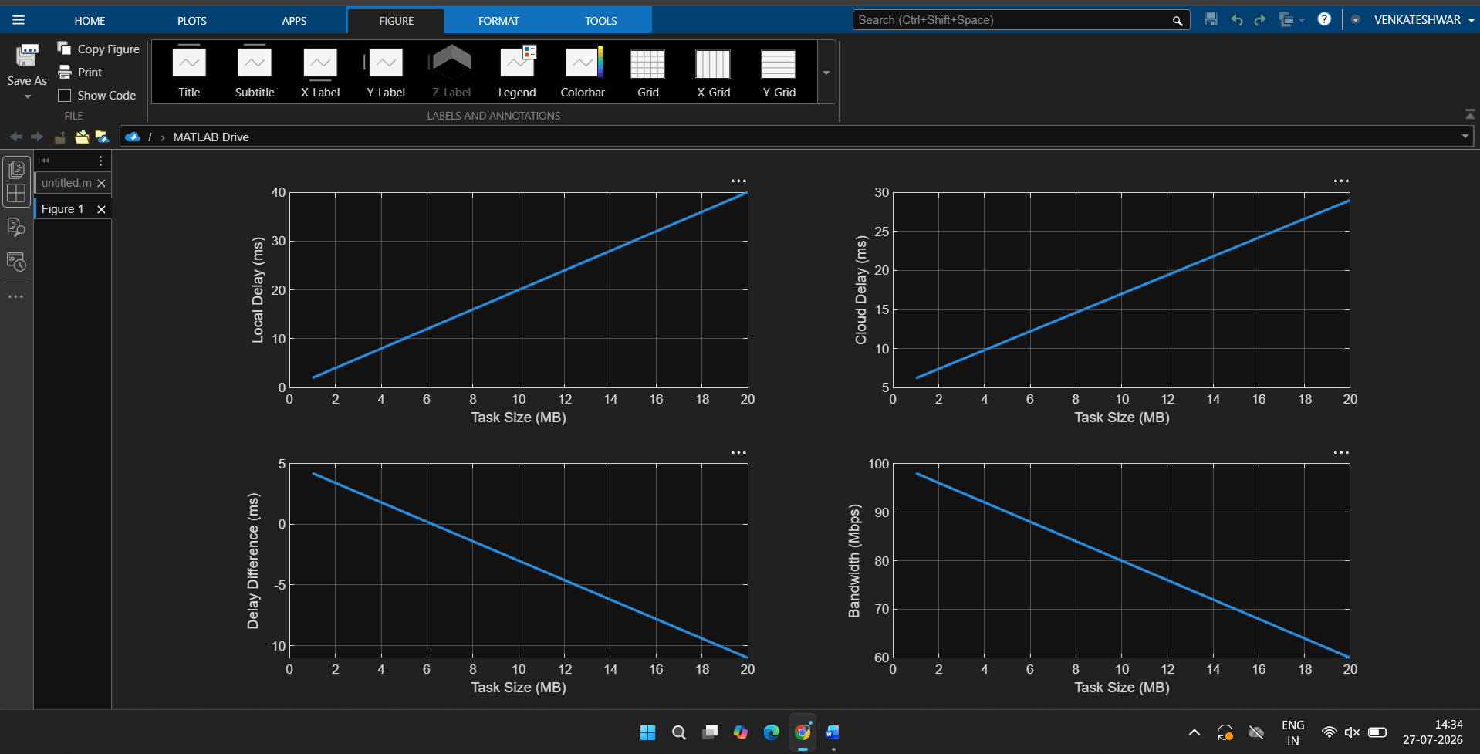
RESULT:
The edge computing model was successfully simulated. The results indicate that local processing provides lower delay than cloud processing for small and medium task sizes, thereby reducing overall latency and improving response time.

39. Simulation of Smart City IoT Traffic
Objective:
To simulate smart city IoT traffic performance by varying sensor count, delay, packet delivery, bandwidth, and throughput.
Parameters: Sensor Count, Delay, Packet Delivery, Bandwidth, Throughput
MATLAB CODE:
clc;
clear;
close all;

sensors = 100:100:1000;

delay = 5 + 0.02*sensors;
PDR = 99 - 0.01*sensors;
bandwidth = 100 - 0.05*sensors;
throughput = 10 + 0.04*sensors;

figure;
subplot(2,2,1);
plot(sensors,delay,'LineWidth',2);
xlabel('Number of Sensors');
ylabel('Delay (ms)');
grid on;

subplot(2,2,2);
plot(sensors,PDR,'LineWidth',2);
xlabel('Number of Sensors');
ylabel('Packet Delivery (%)');
grid on;

subplot(2,2,3);
plot(sensors,bandwidth,'LineWidth',2);
xlabel('Number of Sensors');
ylabel('Bandwidth (Mbps)');
grid on;

subplot(2,2,4);
plot(sensors,throughput,'LineWidth',2);
xlabel('Number of Sensors');
ylabel('Throughput (Mbps)');
grid on;
OUTPUT:
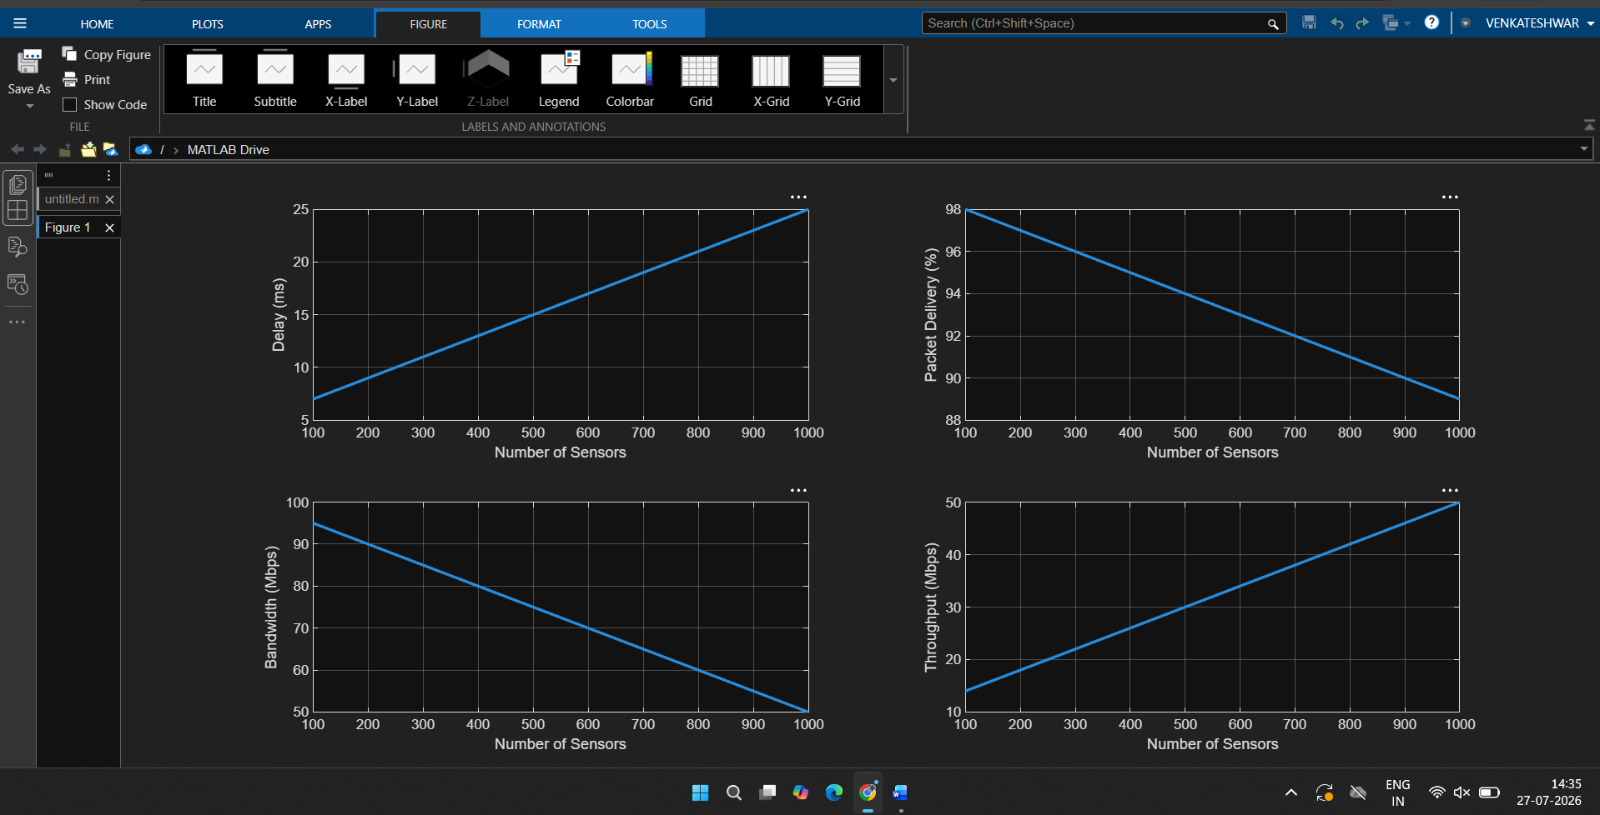
RESULT:
The Smart City IoT traffic model was successfully simulated. The results show that increasing the number of sensors increases network delay and throughput demand, while packet delivery ratio and available bandwidth decrease due to higher network congestion.

40. Simulation of AI-Based Wireless Optimization
Objective:
To simulate AI-based wireless optimization by evaluating prediction accuracy, throughput, delay, resource allocation, and energy efficiency.
Parameters: Prediction Accuracy, Throughput, Delay, Resource Allocation, Energy Efficiency
MATLAB CODE:
clc;
clear;
close all;

accuracy = 50:5:100;

throughput = 20 + 0.4*(accuracy-50);
delay = 50 - 0.5*(accuracy-50);
resource = 60 + 0.6*(accuracy-50);
energy = 70 + 0.3*(accuracy-50);

figure;
subplot(2,2,1);
plot(accuracy,throughput,'LineWidth',2);
xlabel('Prediction Accuracy (%)');
ylabel('Throughput (Mbps)');
grid on;

subplot(2,2,2);
plot(accuracy,delay,'LineWidth',2);
xlabel('Prediction Accuracy (%)');
ylabel('Delay (ms)');
grid on;
subplot(2,2,3);
plot(accuracy,resource,'LineWidth',2);
xlabel('Prediction Accuracy (%)');
ylabel('Resource Allocation (%)');
grid on;
subplot(2,2,4);
plot(accuracy,energy,'LineWidth',2);
xlabel('Prediction Accuracy (%)');
ylabel('Energy Efficiency (%)');
grid on;
OUTPUT:
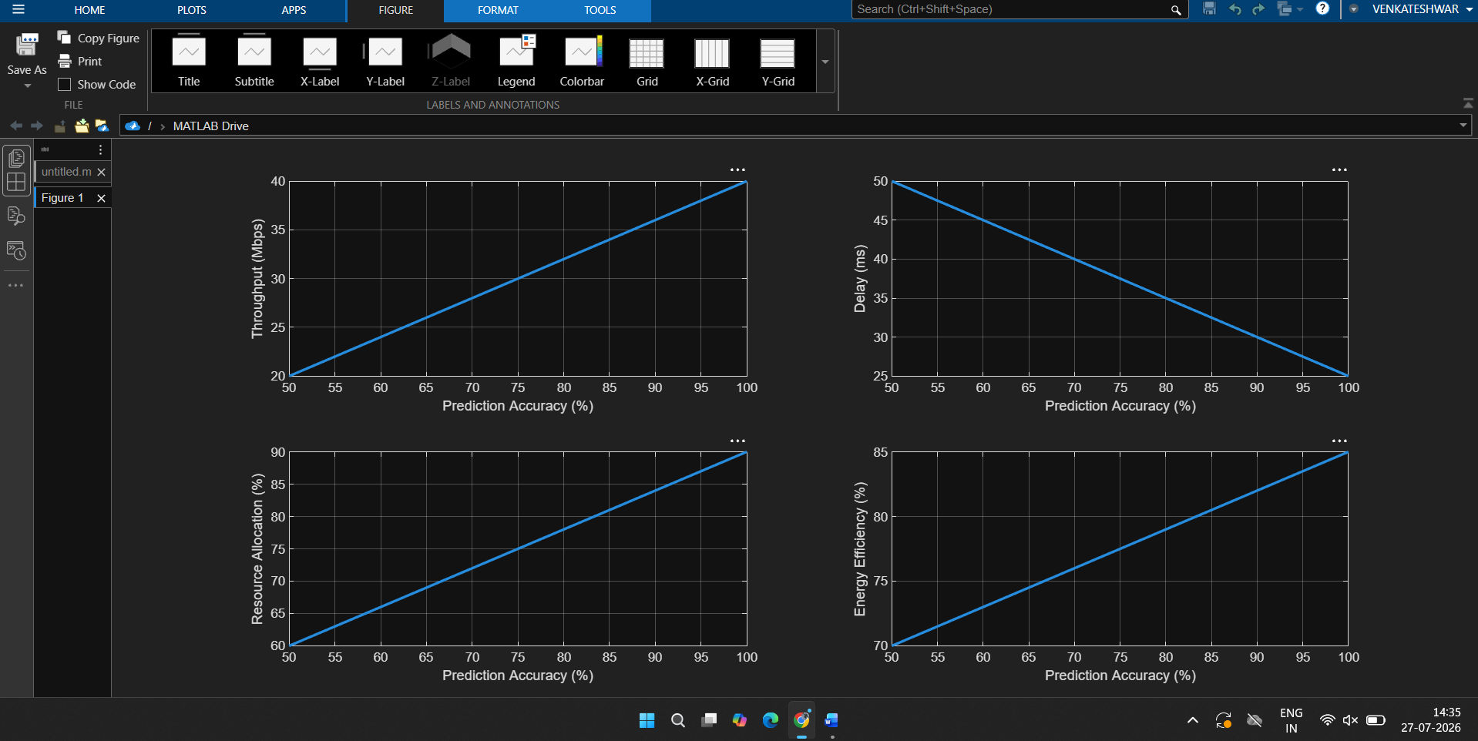
RESULT:
The AI-based wireless optimization system was successfully simulated in MATLAB. The results demonstrate that higher prediction accuracy improves throughput, resource allocation, and energy efficiency while reducing communication delay, leading to enhanced overall network performance.

Simulation Task
Criteria | Weightag e | Level 4 (Exemplary) | Level 3 (Proficient) | Level 2 (Developing) | Level 1 (Beginning)
Conceptual Understanding | 20%  (4 marks ) | Demonstrates strong understanding of underlying concepts in the simulation | Shows good understanding with minor gaps | Partial understanding; some misconceptions | Lacks understandin g of key concepts
Model Design | 25%  (5 marks ) | Develops accurate, well-structured simulation/mod el  independently | Develops correct model with minor errors | Model is incomplete or requires guidance | Unable to develop a proper model
Tool Usage | 20%  (4 marks ) | Uses simulation tools effectively with  correct setup and execution | Uses tools with minor errors or guidance | Limited ability to use tools properly | Unable to use simulation tools
Analysis of Results | 20%  (4 marks ) | Provides clear, logical analysis and meaningful interpretation  of results | Analysis is reasonable with minor gaps | Superficial analysis; limited interpretation | Unable to analyze or interpret results
Documentatio n | 15%  (3 marks ) | Presents results clearly with proper documentation  and structured reporting | Documentation is adequate with minor issues | Poorly organized or incomplete documentation | No proper documentatio n or presentation

